Hotel Facilities

FOOD & DRINK

**Restaurant**

Experience a culinary journey at the restaurant with authentic cuisines, featuring local and international flavours.

**Swimming Pool**

Experience ultimate relaxation at the infinity swimming pool with a breath-taking sunset view. Immerse yourself in the stunning scenery while enjoying a refreshing swim, making your stay an unforgettable one.

**TIE THE KNOT IN STYLE**

**Lawn for Weddings**

Celebrate your special day amidst the breathtaking natural beauty of our resort. Our multiple destination wedding venues in one resort offers a stunning backdrop of picturesque mountains, lush greenery, and serene surroundings for your different occasions like Haldi, Mehandi, Sangeet & Dreamy Wedding. With luxurious amenities, exquisite dining options, and personalized services, our resort is the perfect choice for a memorable and unique wedding experience.

**Corporates**

Escape the hustle and bustle of the city and host your next corporate offsite at our resort. Our state-of-the-art facilities, breathtaking natural surroundings, and luxurious amenities provide the perfect backdrop for a productive and unforgettable event. Our experienced team will work with you to plan and execute a tailored program that meets your specific needs and objectives. With top-notch dining options, team-building activities, and relaxation options, our resort ensures a seamless and successful offsite. Contact us today to plan your next corporate event.

**Facility**

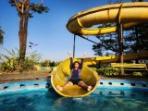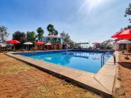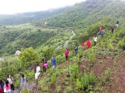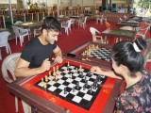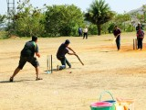

**Water Slide Swimming Pool Rain Dance Activity Jungle Walk Chess Board Cricket Ground**

Experience a day full of fun and relaxation with our One-day package at our resort. From 9 am to 6 pm, indulge in a delicious veg breakfast, veg & Non veg Lunch at Restaurant, and a refreshing veg hi-tea. The package also includes complimentary access to a range of activities such as a swimming pool, water slides, rain dance, common karaoke, DJ, and jungle trek, subject to availability. You can also enjoy our Game Zone Make the most of your day with our One-day package, and create unforgettable memories with your loved ones.

**Amenities:**

* Room Service
* Car Rental
* Children's Play Area
* 24-hour front desk
* Restaurant
* Coffee Maker
* Refrigerator
* Concierge
* Temperature checks are available to guests
* Wheelchair Access
* Swimming Pool - Outdoor
* Contactless check-in and check-out are available
* Free Continental Breakfast
* Guests are provided with free hand sanitizer
* Individually-wrapped food options are available
* Game Room
* Balcony
* Full Kitchen
* Non-Smoking Facility

Premium Rooms with All Meals

The Premium Room has an elegant interior with elegant flooring. The room has a private balcony or sit-out area with a swing overlooking the verdant hills. The room has all the necessary amenities such as queen size bed, TV, AC, ensuite bathroom, toiletries, and much more

Premium Rooms with All Meals (Excl. Tax)

**Room Amenities**

Air conditioning

Television with Satellite/cable channels

Room service

Coffee/tea maker

Wifi

Room Size 37.39 m²

**Inclusions Stay**

**Meals**

Breakfast, lunch, hi-tea, and dinner meals are included with your stay.

**View Child/baby policy**

Children aged 0-5 years can accompany the adults completely free of cost. Children between 6-11 years will incur extra charges.

**Extra Guest Policy**

* Premium Room has a maximum occupancy of 3 people.
* An extra Adult/ Child can be accommodated at an additional charge.
* There is a queen-sized bed in the room for 2 people and an extra mattress can be arranged as per requirement at Rs. 1500 per mattress.

Maharaja Room with All Meals

Stay in a spacious and comfortable Maharaja Room having a royal interior. The room is equipped with all the modern amenities such as canopy style king bed, TV, AC, room service(chargeable), sofa, table, wardrobe, and ensuite bathroom. The room has a private balcony overlooking the mesmerizing hills and Bhama lake Backwater.

**Room Amenities**

Air conditioning

Television with Satellite/cable channels

Room service

Coffee/tea maker

Wifi

**Room Size**

37.16 m²

**Meals**

Breakfast, lunch, hi-tea, and dinner meals are included with your stay.

**View Child/baby policy**

Children aged 0-5 years can accompany the adults completely free of cost. Children between 6-11 years will incur extra charges.

**Extra Guest Policy**

* Maharaja Room has a maximum occupancy of 3 people.
* An extra Adult/ Child can be accommodated at an additional charge.
* There is a king-sized bed in the room for 2 people and an extra mattress will be provided as per requirement.

**Tent**

4:00 pm Check In

5:00 pm Welcome Drink & Snack🍵

5:30 pm A nature trail in the farm to experience the beautiful “farm” and other wondrous things around.

6:00 pm Indoor & Outdoor games

7:30 pm Music🏸

8:00 pm Barbeque (BBQ)🍡Limited} 🍱

9:30 pm Dinner

11:00 am Get a cozy sleep inside your tent

7:00 am Wake up early morning to enjoy the sunrise.

9:00 am Tea & breakfast☕🥗

11:00 am Check out

**Day package**

**Game room setup**

Pool Table

Carrom with Stand

Chess

Badminton

Foot ball

Volleyball with net

Foosball Table soccer

Cricket

Soft Archery

Badminton

Dart Game

Cards

Bullock cart

Bhama lake Resort

* [HOME](https://websites.godaddy.com/)
* [SHOP](https://websites.godaddy.com/shop)

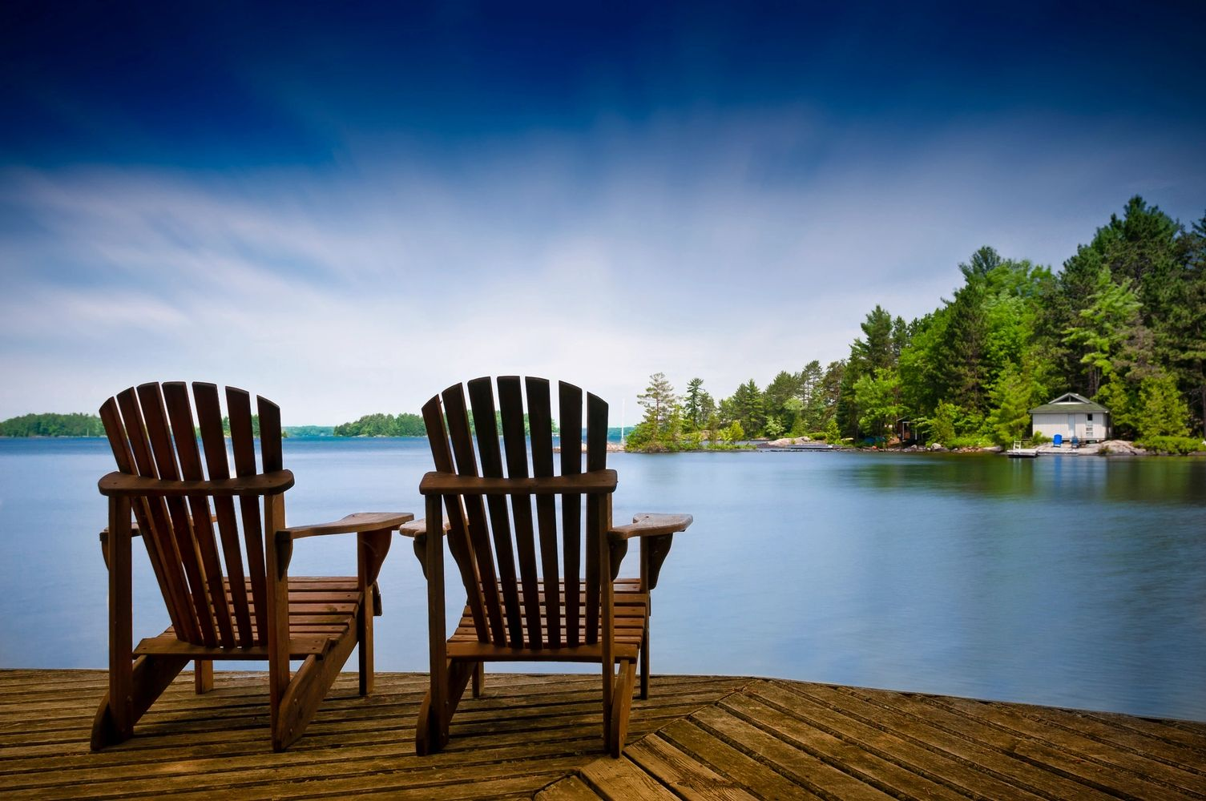Update

WELCOME

Experience Nature's Best at Bhama lake Resort Resort

Find your oasis at our picturesque lake resort. Unwind and reconnect with nature.

[**DISCOVER MORE**](https://websites.godaddy.com/)

ABOUT BHAMA LAKE RESORT

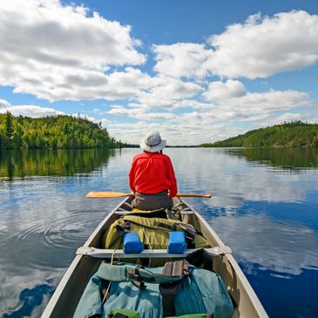

Our Location

Our resort is located in the heart of the beautiful Bhama lake Resort area, surrounded by stunning natural scenery and a variety of outdoor activities. Whether you're looking to relax in the peaceful setting or explore the great outdoors, our location is perfect for you.

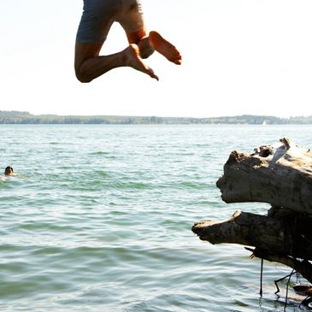

Our Accommodations

We offer a range of accommodations to suit your needs, from cozy cabins to spacious lakefront suites. All of our rooms are equipped with modern amenities and offer breathtaking views of the lake and surrounding mountains.

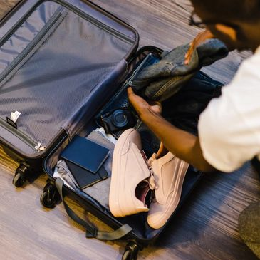

Our Activities

There's always something to do at Bhama lake Resort, whether you're looking to relax on the beach, go fishing, or take a hike in the mountains. We offer a wide range of activities to suit all ages and interests.

**refund & Cancellation; Policy:**

Within 30 days advance notice,10%will be charged as retention charge.

Within 30-15 days of date of arrival,50%will be charged as retention charge.

Within 15-07 days of date of arrival,75%will be charged as retention charge.

Within 07 days of date of arrival no refund.

Retention will be levied for all days of confirm booking in case of no show.